QUESTIONS by ML 260619

## Correlation

1. Justin wrote: “The correlations don't use as many variables that aren't interesting, so it cleans up their presentation”. I am sorry, but I don’t understand the sentence. If it means that you Justin don’t provide us the exact correlation coefficients I have requested, how do we report these balls? Blue is what? Red? Small ones? Big ones?

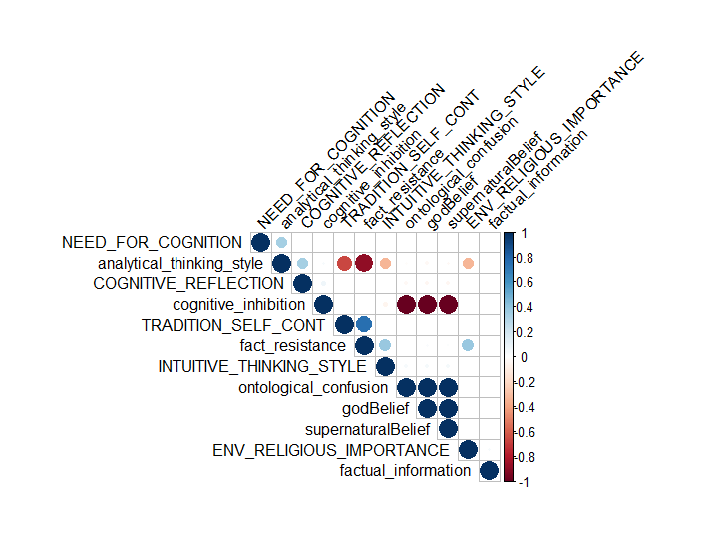

For this, it meant that I didn’t put in all of the variables that we have in our analysis, as we discussed over the skype, many of those weren’t theoretically interesting at all, and many are just there for mathematical purposes, so I attempted to just trim it to what we’ve needed.

As the legend presents on the right side, blue are positive correlations, red are negative. I’ve now included the matrix of all correlations is presented below, asterisks represent significant correlations. Table below:

|  |  |  |  |  |  |  |  |  |  |  |  |
| --- | --- | --- | --- | --- | --- | --- | --- | --- | --- | --- | --- |
|  | TRADITION_SELF_CONT | INTUITIVE_THINKING_STYLE | COGNITIVE_REFLECTION | NEED_FOR_COGNITION | ENV_RELIGIOUS_IMPORTANCE | fact_resistance | cognitive_inhibition | factual_information | ontological_confusion | analytical_thinking_style | godBelief |
| TRADITION_SELF_CONT |  |  |  |  |  |  |  |  |  |  |  |
| INTUITIVE_THINKING_STYLE | 0.27 |  |  |  |  |  |  |  |  |  |  |
| COGNITIVE_REFLECTION | -0.24 | -0.24 |  |  |  |  |  |  |  |  |  |
| NEED_FOR_COGNITION | -0.26 | -0.21 | -0.03 |  |  |  |  |  |  |  |  |
| ENV_RELIGIOUS_IMPORTANCE | 0.28 | 0.15 | -0.21 | -0.24 |  |  |  |  |  |  |  |
| fact_resistance | 0.90**** | 0.54 | -0.31 | -0.33 | 0.55 |  |  |  |  |  |  |
| cognitive_inhibition | 0.06 | -0.04 | 0.24 | 0.13 | 0.08 | 0.06 |  |  |  |  |  |
| factual_information | -0.06 | -0.09 | -0.12 | -0.12 | -0.02 | -0.07 | 0.09 |  |  |  |  |
| ontological_confusion | -0.06 | 0.03 | -0.23 | -0.13 | -0.08 | -0.07 | -1.00**** | -0.09 |  |  |  |
| analytical_thinking_style | -0.86*** | -0.54 | 0.46 | 0.47 | -0.55 | -0.97**** | 0.03 | 0.01 | -0.02 |  |  |
| godBelief | -0.05 | 0.04 | -0.23 | -0.14 | -0.08 | -0.05 | -1.00**** | -0.09 | 1.00**** | -0.04 |  |
| supernaturalBelief | -0.06 | 0.04 | -0.23 | -0.14 | -0.08 | -0.05 | -1.00**** | -0.09 | 1.00**** | -0.03 | 1.00**** |

2. Now, when fact resistance is included (with need for cognition and cognitive reflection), why also analytic thinking style is included? There is no other analytic style than those three.

In the past, if one was missing and the others not, it was an issue, so all of them were included. When it comes to the publication, I can include only those that we want, but I didn’t want them to be missing as it was a problem in the past.

3. Many variables are missing: trauma, family, culture, presence of atheist, level of education and study topic. We have to report correlations for all variables whether they were low or high. These are needed not only by the journal but also because I am not able to write or think about the discussion without more exact information.

Indeed, those were variables that we said before weren’t interesting. However, a full list of all correlations can be found in the excel sheet I’ve put on slack (its too many to have in one table in a word document). Its also in an html file (you can open it in google chrome). Here again astrisks are used to report typical significance by p values.

## Regression

We also utilized regression to understand the positive and negative effects of different variables on god beliefs and supernatural beliefs.

In order to better understand the key variables of our model, we can trim down to just the most important variables from the literature. This regression results are found below.

4. Why not from the correlations? It would be extremely difficult to justify this by ‘the literature’ and it is a normal way to exclude variables that do not correlate with the dependent variable.

|  |  |  |  |
| --- | --- | --- | --- |
| Variable | Beta (standardized) | t | p |
| INTELLIGENCE | -0.0039 | -199.49 | <.01 |
| TRAD_SELF_CONT | 0.0039 | 115.22 | <.01 |
| INTUITIVE_THINKING_STYLE | 0.0019 | 79.30 | <.01 |
| COGNITIVE_REFLECTION | -0.0039 | -194.13 | <.01 |
| NEED_FOR_COGNITION | -0.0039 | -199.77 | <.01 |
| Fact_resistance | 0.016 | 421.99 | <.01 |
| Cognitive_inhibition | 0.00034 | 1.80 | .07 |
| Ontological_confusion | 0.99 | 5243.04 | <.01 |

General model statistics: *RSE* = 2.05, *df* = 19991, *r2* = 1, *f* = .000000032(8,19991), *p* < .01.

If it is by correlations or regression, it is largely up to you guys I think. As you know though, there are different assumptions about the two methods, and their interpretation. As we are aiming to suggest a relationship between all of the variables and god belief (although they might not be equal, they are not necessarily independent), as opposed to just any one variable at a time independently, it makes the most theoretical sense to also present a regression.

5. The results are not sensible. Ontological confusions cannot explain everything (they can’t have a beta which is 250 times higher than the beta of the other variables)

When it comes to these betas, remember, this is just for our simulated data, not for a psychological experiment, so we don’t need these betas to align perfectly for our purposes. Instead, we should focus on directionality. We can always weight ontological confusions in a later publication to match more reliable betas from the literature. At this point though, it makes the most sense for us to focus on the directionality of these relationships and later we can revise it for relative weighting, but I think we can argue that this is beyond the scope of our current publication. So we should ask ourselves if it is the directionality of the results that are not sensible or just the beta for ontological confusion?

We were somewhat surprised to see the insignificant relationship with cognitive_inhibition in the data. To further investigate our system we used the Lavaan package to create an SEM of a mediation model to test that the relationship between ontological confusion and god beliefs was mediated by cognitive inhibition. Indeed, we found that the relationship between cognitive inhibition and god beliefs is mediated by ontological confusion and that this relationship can be expressed as a full mediation model.

6. Which model was tested, green or blue? The green model is not sensible, but the blue is.

Oh, sorry, that is my fault. The blue model was tested. That was super confusing on my part. (changed the color there so we don’t make this report a Stroop task).

7. If the blue model was tested (as the figure hints), how can we justify this? Cognitive inhibition did not predict God belief, so there is no reason to examine what explains this relationship (because there is no relationship). However, cognitive inhibition had a big red ball for both God belief and ontological confusions in the correlation matrix. Do they indicate strong relationships? If yes, we might justify the SEM by these associations, or?

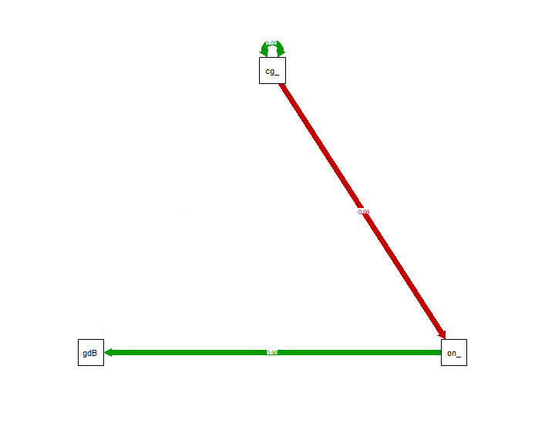

There is a relationship in the literature correct? That could justify further investigation. In our model, we found that this is mediated. So we’re checking that the relationship proposed in the literature is, at least in some way, captured by our model. We can also justify this because of the correlations yes. It just highlights that difference in assumption that I noted earlier.

# Optimization

* For Tommy only

# Calibration



8. These results are scary strange. For example, traditional values and intuitive style ‘explain’ both the conversion from religious to atheist and from atheist to religious etc. I hope that the explanations for this table Justin promised to write clear things up.

For now, let’s set this aside since its not going in this publication.

**9. PLEASE JUSTIN, tell us the reason why ontological confusions are not included! I know that this is one of the hundred times asked questions, but the response that ontological confusion is a parameter is just not enough**. I repeat myself: “. So please, I would really appreciate it if I could get some … text sections about these issues intended to be included in the manuscript (keeping in mind the intelligence researcher R. Sternberg’s tip to get articles published: ”Write for a somewhat broader and technically less skilled audience than you expect to read the article”).”

Again, we should set this aside. As we’ve mentioned before, it comes down to the fact that ontological confusion is effectively an output in our model, not an input. So we can’t manipulate an output in an optimization experiment. We can only set inputs and see which one gets closest to our desired output. We can’t currently optimize for multiple outputs at once, so we only chose god beliefs to be our target for the optimization.

10. And also in general, the variables included in this analysis should either be exactly the same as in the correlation table, or the exclusion of some variables should be clearly justified.

As these are limited to only the set of parameters that we can input into the model, it wouldn’t make sense that they are all exactly the same as some of our correlations are mechanisms and outputs. In any case, we should leave the optimizations aside for now as discussed in our last skype.

# Key Features

Our AI system determined that, when classifying a person, based on the input parameters, as a “believer” or “nonbeliever” that the top-5 most important data in determining the classification decision are from the following variables (ranked in order of importance):

Cognitive inhibition

Analytical thinking style

Tradition and self continuity

Frequency of trauma

Presence of atheists

11. As we discussed when we skyped, the results for this believer-nonbeliever classification are quite different from the regression analysis results (which is of course logical, for the most part). Justin told that the reason is that the relationship between the predictors is asymmetrical for believers and unbelievers. Is there any way to examine how? Or should we just write in the Discussion, that “the predictors were asymmetrical for believers and unbelievers but we have no idea how”?

I think we should just say that they’re asymmetrical and effectively we have no idea how. It is the biggest issue with AI (its called the interpretability problem) and currently diving into that would be beyond the scope of the paper, and we wouldn’t solve it anyway. We can just say that the asymmetry was discovered by machine learning, and leave it at that I think.

12. What about the flows? They were included in the early version, and they caused me great headache when writing the Introduction. Is there a similar flow table coming up?

We can include the visualization of the flows if we want. That can always be inserted as a figure.

When I get answers to all (literally all) these questions, I am eager to write the draft for the Discussion 😊.

😊 hopefully these help. If not let me know and I’ll keep at it!